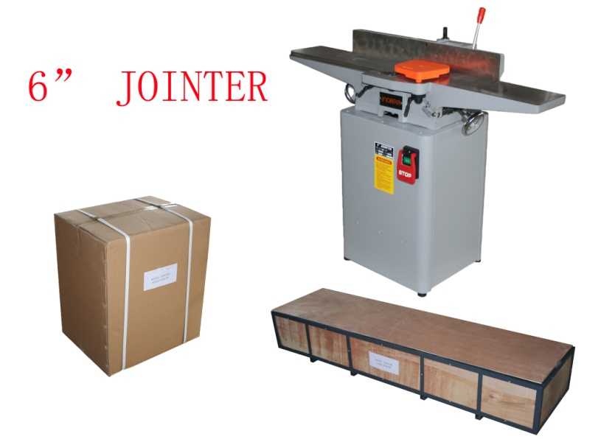 | MOTOR | Output: 1HP
 | TABLE | Length: 1215mm  Width :184mm
 | CUTTERHEAD | Speed:4400r.p.m/50Hz  5200r.p.m/60Hz  Number of knives:3  Diameter:61mm
 | FENCE | Size: 708x98mm  Tilt: 45ºin and out
 | CUTTING CAPATITY | Width: 152mm  Depth: 3.175mm  Rabbeting:12.7mm
 | WEIGHT | N.W.: Body:76kg Stand:36kg  G.W.: Body:85kg Stand:36.5kg
 | PACKING MEASURE | Body:L1280xW400xH250mm  Stand:L560xW440xH650mm

6“JOINTER/JP6

