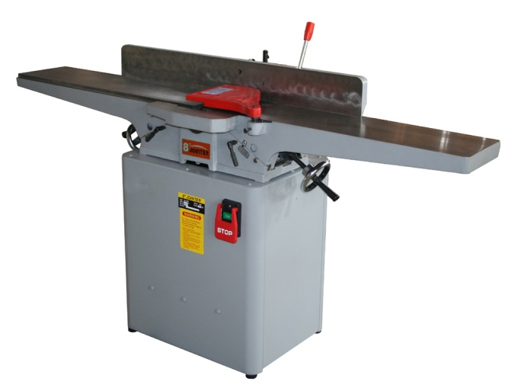  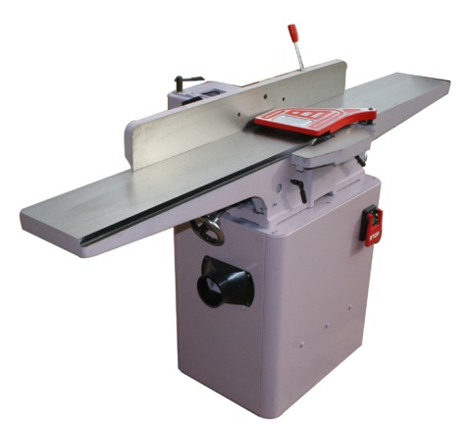 | MOTOR | Output: 2HP
 | TABLE | Length: 1800mm  Width :230mm
 | CUTTERHEAD | Speed:4800r.p.m/50Hz  5900r.p.m/60Hz  Number of knives:4  Diameter:75mm
 | FENCE | Size: 1010x120mm  Tilt: 45ºin and out
 | CUTTING CAPATITY | Width: 200mm  Depth: 3.175mm  Rabbeting:12.7mm
 | WEIGHT | N.W.: Body:141kg Stand:52kg  G.W.:Body:155kgStand:54.5kg
 | PACKING MEASURE | Body:L1880xW440Xh270mm  Stand:L600xW470xH650mm
8” JOINTER/JP801

